|  |  |
| --- | --- |
| POE: Website Proposal  POE: Website Proposal | NOLWAZI ELAINE NYEMBE  WEDE5020 |

Table of Contents.

Contents

1. Organisation Overview. 3

2. Website Goals and objectives. 4

3. Proposed Website Features and Functionality 5

4. Design and User Experience. 6

5. Technical Requirements. 7

6. Timeline and Milestones. 8

7. Budget 9

8. References 10

**Website Proposal for Hydrate with inspo**

**Organization Overview**

Hydrate With Inspo is Dedicated to promoting hydration and minimizing single-use plastic waste, Hydrate with Inspo is an environmentally conscious company that specializes in premium, sustainable water bottles. For those who care about their health and the environment, the company wants to offer fashionable, long-lasting, and useful bottles.

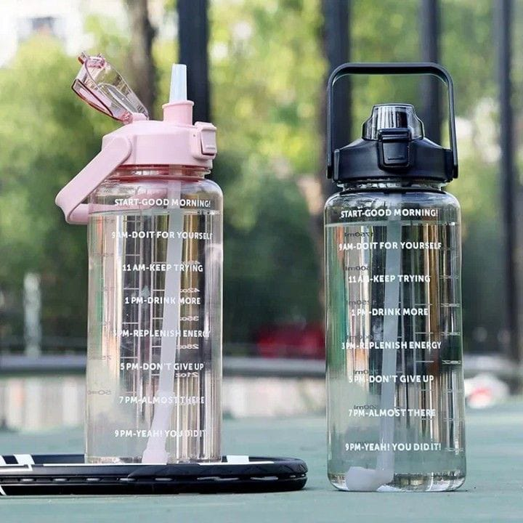  
<https://images.app.goo.gl/ZvU9MSV9sERcYvfq7>

](https://images.app.goo.gl/hSBtTMWgvSeVJh4P8)

<https://images.app.goo.gl/hSBtTMWgvSeVJh4P8>

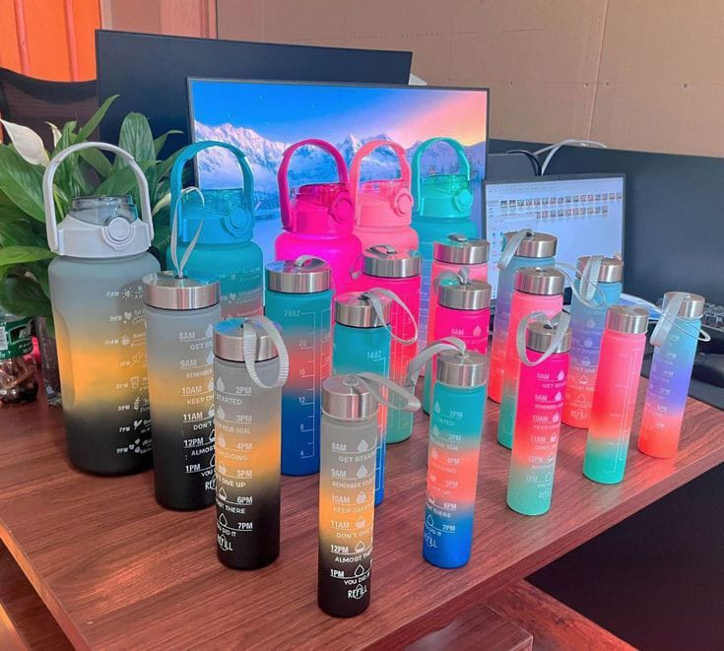

<https://pin.it/4aYjPPOq6>

Emphasize Hydrate's commitment to environmental **Website Goals & Objectives**

**Goals:**

* Increase internet sales and brand awareness.
* Teach consumers about sustainability and staying hydrated.
* Create a smooth user journey from perusing to purchasing.

**Objectives:**

* Open an eCommerce store that is completely operational.
* sustainability and high-quality products.
* Offer educational content, such as blogs and hydration advice. Through newsletters and reviews, cultivate client loyalty.

**Current Website Analysis**

The current website may lack:

* A modern, responsive design for mobile users.
* An optimized eCommerce system.
* Clear brand messaging around sustainability.
* SEO best practices and content to engage customers.

**Opportunities:**

* Redesign the website for a more modern, mobile-friendly experience.
* Integrate secure checkout and payment options.
* Improve SEO for better visibility and organic traffic.
* Offer a blog section to educate customers about hydration and sustainability.[1]

**Proposed Features & Functionality**

1. **E-Commerce Store**: Product pages with detailed descriptions, secure checkout, and multiple payment options.
2. **Responsive Design**: Optimized for all devices (desktop, tablet, mobile).
3. **Blog Section**: Articles about hydration, fitness, and sustainability.
4. **Social Media Integration**: Display Instagram/Pinterest feeds.
5. **Customer Reviews**: Encourage reviews to build trust and inform potential buyers.
6. **Newsletter Signup**: Capture leads for marketing and promotions.
7. **Live Chat/Support**: Quick assistance for users.

**Design & User Experience**

* **Minimalist & Clean Design**: Soft blues and greens to reflect hydration and sustainability.
* **Easy Navigation**: Intuitive structure to facilitate product discovery and quick checkout.
* **High-Quality Imagery**: Showcase bottles in real-life, lifestyle settings.

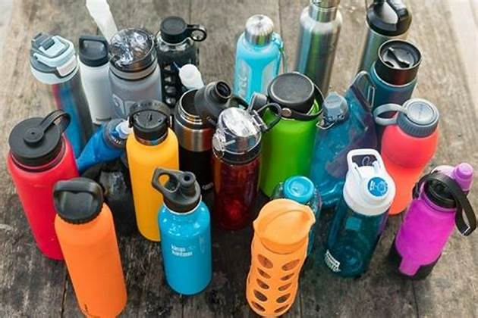

<https://changefest.com.au/bring-a-water-bottle/>

**Technical Requirements**

* **CMS**: WordPress or Shopify for easy content management.
* **E-Commerce Integration**: Shopify or WooCommerce.
* **SEO**: On-page SEO (keywords, meta descriptions) and mobile optimization.
* **Security**: SSL certificate and secure payment gateways (Stripe, PayPal).

**Timeline & Milestones**

* **Phase 1 (1 Week)**: Discovery and planning.
* **Phase 2 (2-3 Weeks)**: Design and prototyping.
* **Phase 3 (4-6 Weeks)**: Development and integration.
* **Phase 4 (2 Weeks)**: Testing and launch.

**Total Timeline: 8-12 Weeks**

**Budget Estimate**

* **Design & Development**: R4,500 - R7,000
* **E-Commerce Integration**: R2,000 - R3,000
* **Content Creation**: R1,000 - R2,000
* **Maintenance & Support**: R1,000 - 1,500
* **Total**: R8,500 - R13,500

**Conclusion**

# The suggested Hydrate website will boost sales, provide a smooth user experience, and be consistent with your sustainability principles. This website will increase the market presence and visibility of your brand thanks to its cutting-edge design, eCommerce features, and captivating content. We are eager to work with you.

**References**

ChangeFest (2024) *Bring a Water Bottle*. Available at: <https://changefest.com.au/bring-a-water-bottle/> (Accessed: 6 May 2025).

HydrateWithCore (2024) *Sustainability*. Available at: <https://hydratewithcore.com/sustainability/?utm_source=chatgpt.com> (Accessed: 6 May 2025).

The New York Times (2024) *Best Water Bottle*. Available at: <https://www.nytimes.com/wirecutter/reviews/best-water-bottle/> (Accessed: 6 May 2025).

# [https (Dillon, 2025)](https://www.nytimes.com/wirecutter/reviews/best-water-bottle/)

[://www.nytimes.com/wirecutter/reviews/best-water-bottle/](https://www.nytimes.com/wirecutter/reviews/best-water-bottle/)

1.